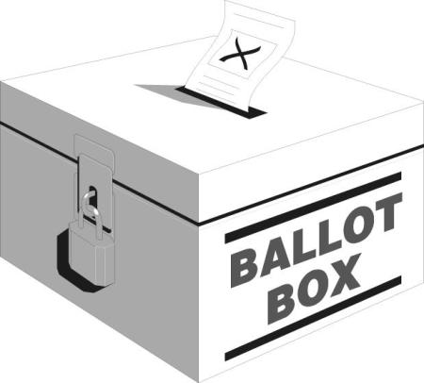
Electoral List
(Parish)
(Year)

(Type any divisional information etc here)
The Candidates were (1st Candidate Name)
(2nd Candidate Name)
(3rd Candidate Name)

Surname | Given Name | Abode | Voted for
xxxxxxxxxxxxxxxxx | xxxxxxxxxxxx | xxxxxxxxxxxxxxxxxxxxxx | Surname | Surname | Surname
xxxxxxxxxxxxxxxxx | xxxxxxxxxxxx | xxxxxxxxxxxxxxxxxxxxxx | Yes
xxxxxxxxxxxxxxxxx | xxxxxxxxxxxx | xxxxxxxxxxxxxxxxxxxxxx |  | Yes
xxxxxxxxxxxxxxxxx | xxxxxxxxxxxx | xxxxxxxxxxxxxxxxxxxxxx |  |  | Yes
xxxxxxxxxxxxxxxxx | xxxxxxxxxxxx | xxxxxxxxxxxxxxxxxxxxxx | Yes | Yes
xxxxxxxxxxxxxxxxx | xxxxxxxxxxxx | xxxxxxxxxxxxxxxxxxxxxx |  |  | Yes

